BGGN 213 Lecture 3

Q1:

hemoglobin subunit beta [Homo sapiens] 301 301 100% 2e-106 100%

Q2:

Raised E value to 100, some weird things pop up. I don’t trust them. False positives.

Q3:

hemoglobin subunit beta [Homo sapiens] 301 301 100% 2e-106 100% NP_000509.1

I got cytoglobin.

Q4:

Select seq NP_005359.1 myoglobin [Homo sapiens] 80.5 80.5 97% 2e-19 26% NP_005359.1(scored below threshold on previous iteration)

Select seq NP_067080.1 neuroglobin [Homo sapiens]

Q5:

More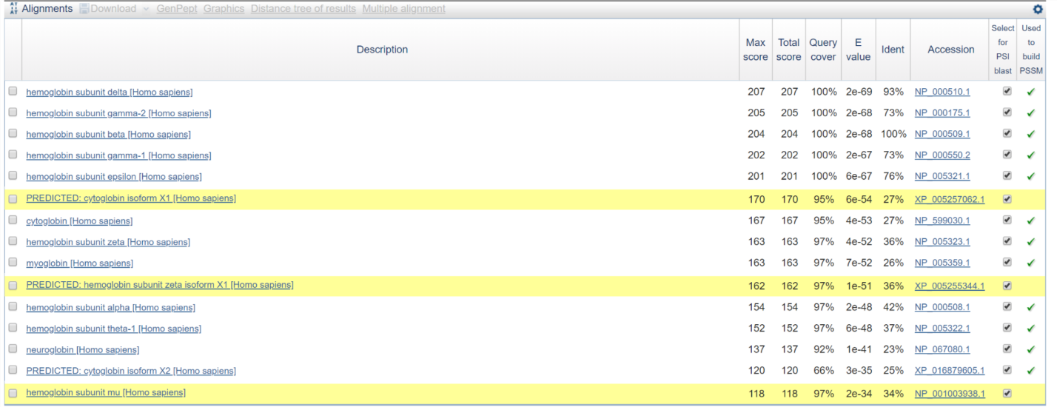

Q6:

Q7:

Much broader than BLAST and first Psi-blast.

We have cytoglobin, myoglobin, neuroglobin

Q8

Yes.

PDB for neuroglobin:1oj6, 4mpm

Q9:

Very quick

Q10:

Most conserved: F at 38 and H at 91